ProQuest Ebook Central and Alma - EDI and EOD workflow | 

Introduction
This document will describe how Ebook Central and Alma are integrated together using EOD, EDI and when necessary an additional bibliographic import profile. That is, it will present the methodology by which the following three aspects of the records are handled:
- Financial (POL order creation)
- Bibliographic (Bibliographic record creation)
- Inventory (electronic portfolio creation)

The following functionality is used to achieve integration:
- EOD for creating bibliographic records, inventory and orders
- EDI for receiving invoices from the vendor
- Import profiles for overlaying bibliographic records

Step one above “EOD for creating bibliographic records, inventory and orders” must be performed first. Steps two and three above can come in any order.

The first action is to run the “New Order” import profile which uses the EOD (embedded order data) file.
At a later stage, in either order, the EDI invoice is received and / or the additional import profile is run for overlaying the records.

This document will show how these three activities can be used together specifically for integrating Ebook Central and Alma.

A note regarding the EDI
In the scenario we are showing here the EDI is used to receive the invoice for the order which is created using the “New Order” import profile.
It is also possible to both create the order and receive the invoice via EDI. In this case the “New Order” import profile would not be used.
That is a different workflow than what is described here and more can be read about this in the EDI section of the On Line help.

The New Order import profile
The EOD file and corresponding “New Order import profile” contains both bibliographic and order-related information. Alma supports either a MARC binary file or a MARC xml file.

- In the “Profile Details” tab:
  - Originating System: ProQuest Ebook Central.
    - Note that you will need to first add this to the table “Originating Systems for MD records” located under “Resource Management Configuration Menu > Record Import”
  - Source format: MARC21 Bibliographic
- In the “Match profile” tab:
  - Non Serial match method: 024 / 035 Match Method
  - Handling method: Automatic
  - Upon match: Merge
  - Merge method: Overlay all fields but local
  - Do not override/ merge record with an older version: Disabled
  - Merge Records and Combine Inventory for Multi-Match Merge and Combine: Disabled
  - Merge Records and Combine Inventory for Multi-Match Merge and Combine Preferred record: Record with the most items
  - Merge Records and Combine Inventory for Multi-Match Secondary record: Delete
  - Merge Records and Combine Inventory for Multi-Match Merge method: Overlay all fields but local
  - Merge Records and Combine Inventory for Multi-Match Update holding call number: Not relevant leave blank
  - Upon no match: Import

- In the “Inventory Information” tab:
  - Inventory Operations: Electronic
  - Portfolio type: standalone
  - Material type: Book
  - Extract access URL from field: 856 subfield u
  - Extract Public note from field: 856 subfield z
  - Default interface name: Optional. Will be whatever your institution has called the interface used for these portfolios
    - This is only relevant if you have chosen “portfolio type = standalone”. If you have chosen “Portfolio type = Part of an electronic collection” then this field is not relevant or appearing in the profile because it will come from the electronic collection.
  - All other fields are not specific to Ebook Central and Alma integration and should be filled in or left blank as desired

- In the “PO Line Information” tab
  - Electronic PO Line type: Electronic Title One Time (might also be “Electronic Book One Time” depending on local customizations)
  - Vendor: ProQuest (or whatever you called the ProQuest vendor in your institution)
  - Vendor Account: Whatever account you created for the ProQuest vendor for Ebook Central
  - PO Line Currency: USD
  - Decimal point location: 2
  - Acquisition Method: Purchase at Vendor System
  - Vendor Reference Number field: 035 subfield a
  - List price field: 980 subfield b
  - Default PO Line owner: Whatever library you want to be the POL owner
  - Fund distribution field: 981 subfield b
  - Default fund: Whatever fund you want to be used if the “Fund distribution field” is not present in the EOD file.
  - Reporting code field: 980 subfield d
  - Note field: 985 subfield a
  - Do not create electronic activation task: Check this if you do not want to have each portfolio later appear in the Electronic Resource Activation Task List

Let’s look at the Import Profile of type “New Order”

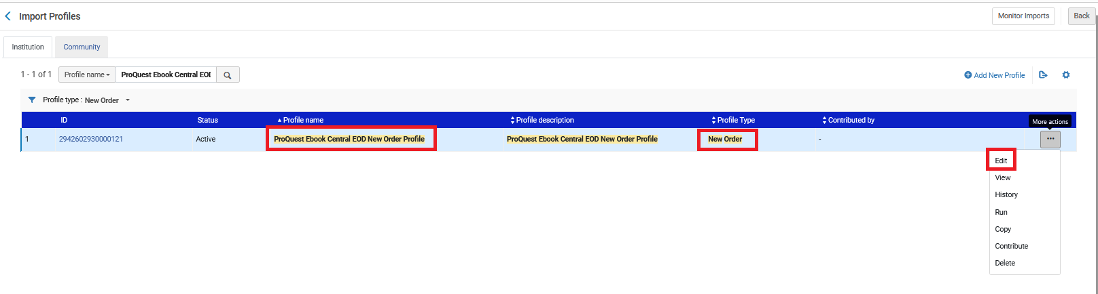

Screenshot “New Order Import Profile” “Profile Details” tab

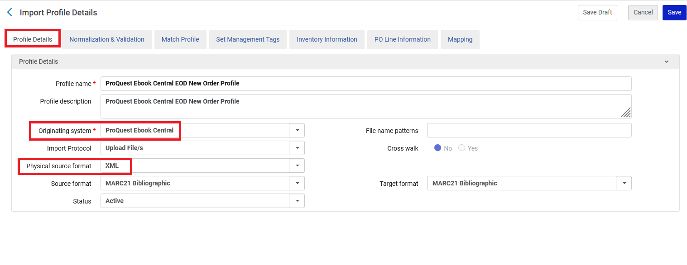

Screenshot “New Order Import Profile” “Match Profile” tab (1 of 2)

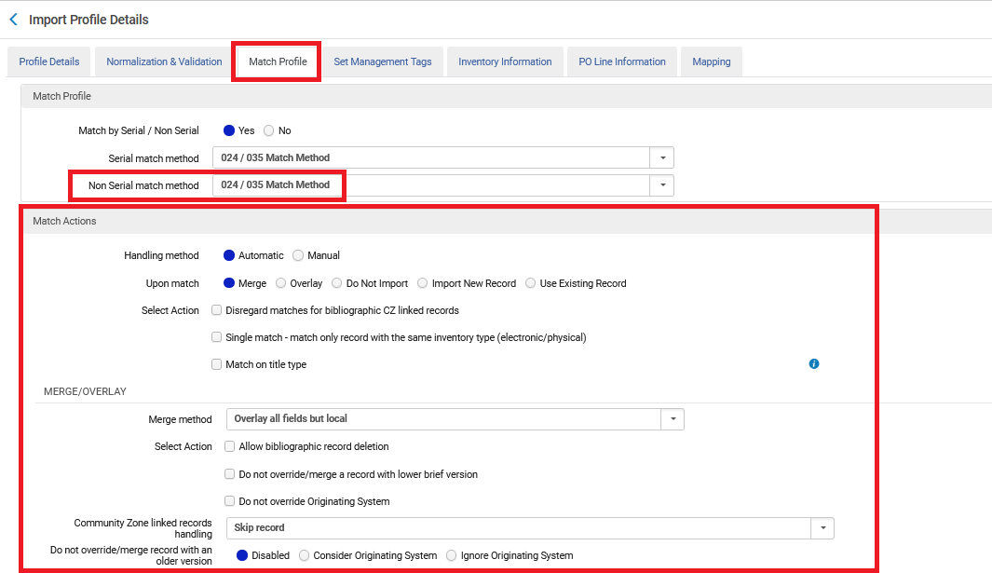

Screenshot “New Order Import Profile” “Profile Details” tab (2 of 2)

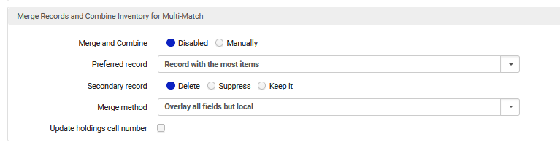

Screenshot “New Order Import Profile” “Inventory Information” tab

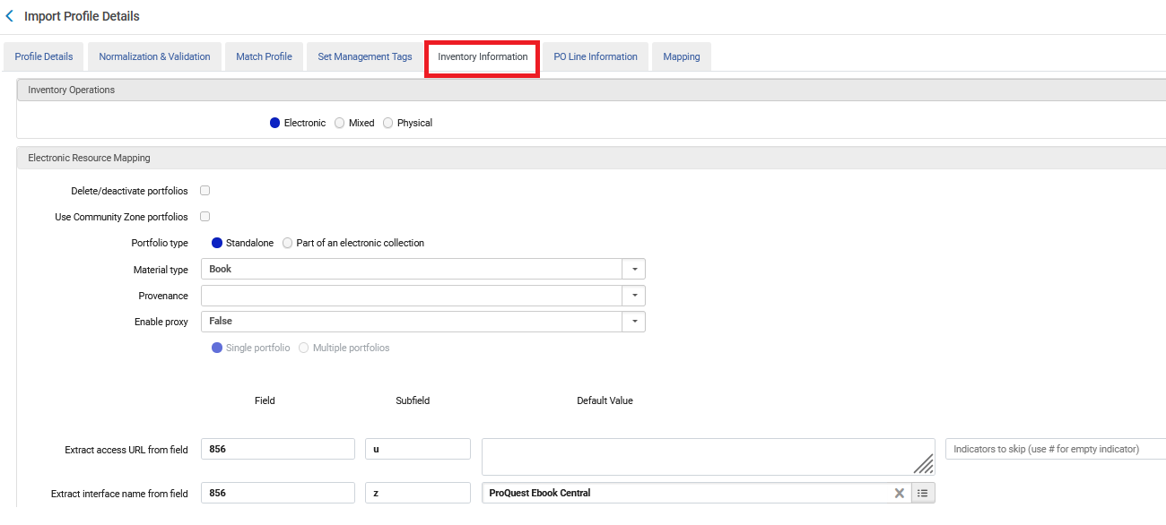

Screenshot “New Order Import Profile” “PO Line Information” tab (1 of 3)

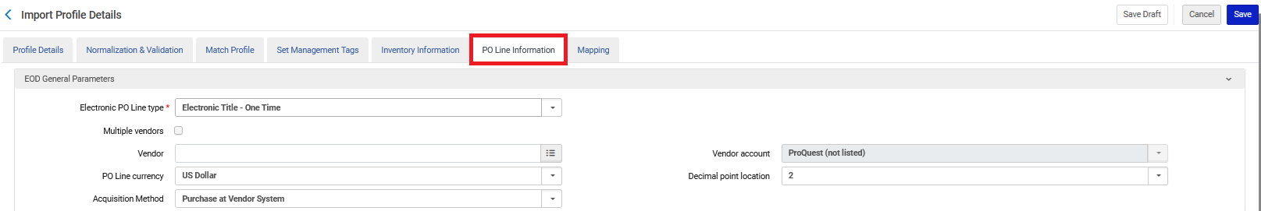

Screenshot “New Order Import Profile” “PO Line Information” tab (2 of 3) (beginning of “EOD Mapping section)

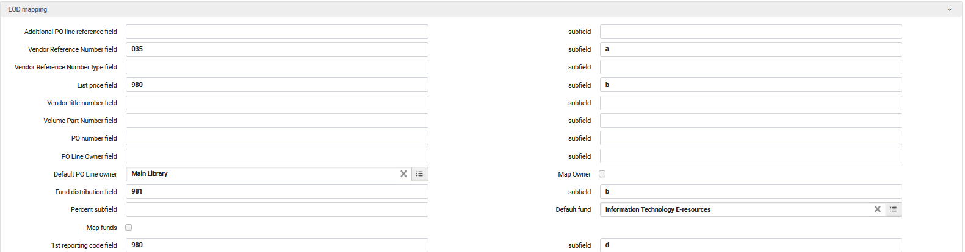

Screenshot “New Order Import Profile” “PO Line Information” tab (3 of 3) (end of “EOD Mapping section)

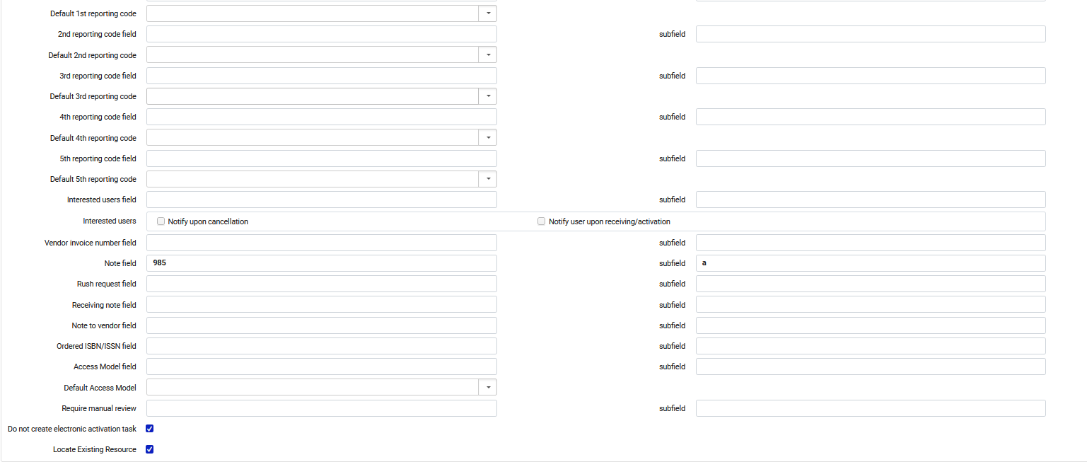

The EOD file received from Ebook Central
See below for the relevant and significant fields of the EOD file which are referred to in the import profile above. The example below is in MARC xml (for easy reading). Alma can import in either xml or binary format according to what is chosen in the “profile details” tab of the import profile.

<datafield tag="020" ind1=" " ind2=" ">
<subfield code="a">9781137550132</subfield>
<subfield code="q">(electronic bk.)</subfield>
</datafield>
<datafield tag="020" ind1=" " ind2=" ">
<subfield code="z">9781137603272</subfield>
</datafield>
<datafield tag="035" ind1=" " ind2=" ">
<subfield code="a">EBC4716611</subfield>
</datafield>
<datafield tag="035" ind1=" " ind2=" ">
<subfield code="a">EBL4716611</subfield>
</datafield>
<datafield tag="035" ind1=" " ind2=" ">
<subfield code="a">(CaPaEBR)ebr11281811</subfield>
</datafield>
<datafield tag="035" ind1=" " ind2=" ">
<subfield code="a">(MiAaPQ)EBC4716611</subfield>
</datafield>
<datafield tag="856" ind1="4" ind2="0">
<subfield code="u">http://ebookcentral.proquest.com/lib/uwsau/detail.action?docID=4716611</subfield>
<subfield code="z">Click Here Please</subfield>
</datafield>
<datafield tag="980" ind1=" " ind2=" ">
<subfield code="b">10000</subfield>
<subfield code="d">REPORTING_CODE</subfield>
</datafield>
<datafield tag="981" ind1=" " ind2=" ">
<subfield code="b">FUND_CODE</subfield>
</datafield>
<datafield tag="985" ind1=" " ind2=" ">
<subfield code="A">NOTE_FIELD</subfield>
</datafield>

The EDI profile
If the institution is receiving invoices via EDI to pay for the above orders, then the “EDI information” tab of the vendor used above (ProQuest LLC) should have the EDI details.
See also below: “Screenshot “EDI Information” tab of the vendor”

- Vendor EDI Attributes
  - Vendor code = 7606958 (This is the ProQuest SAN ID).
  - EDI Type = 31B - US-SAN
  - EDI naming convention = Standard
  - EDI Vendor format = ProQuest
- Incoming
  - Check the box “Incoming”
- Per Organization Unit EDI
  - Vendor code = 7606958 (This is the ProQuest SAN ID).
  - EDI type: 31B - US-SAN

Screenshot “EDI Information” tab of the vendor

